  - Pivot-RP Funding Database: Start Guide!
To get started go to: https://pivot.proquest.com
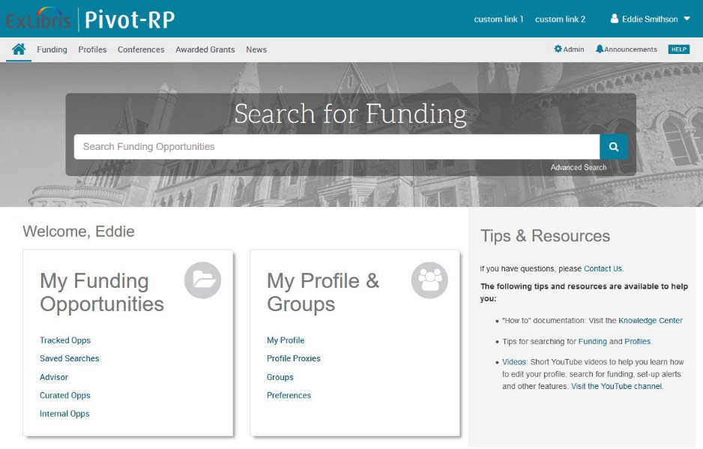

About Pivot-RP – Create an Account today
Pivot-RP is a comprehensive database of active, global funding opportunities across all disciplines and funding types. The service tracks over 20,000 funders including U.S. federal government and non-U.S. government agencies, private foundations, corporate entities, professional societies, international organizations and more – all in one, easy-to-search platform.
With your personal account, you can:
- Receive tailored funding alerts
- Save and revisit funding searches
- Track and get updates on individual funding opportunities
- Share funding opportunities with colleagues

To create an account, click Create Account on the Pivot-RP login page:
- If using your institutional email address/create password, complete the required fields to validate your name and email.
- If Single Sign-On (SSO) is enabled, select your institution from the dropdown and follow the steps to set up your account.

You’ll receive a confirmation email to activate your account — check your spam folder if it doesn’t appear.

Claim your Profile

When you log in, Pivot-RP may prompt you to claim or create a profile. While optional, claiming your profile helps generate automated funding recommendations based on your research interests, publications and grants, and increases visibility for potential collaboration.
Funding Discovery: Basic Search

You can start a search from the home dashboard or by selecting the Funding tab. Use free-text terms, funder/sponsor names, or keywords to find relevant opportunities.

The Search by Keyword feature helps you quickly find terms aligned with your research interests and build queries using one or more keywords. These are curated by Pivot-RP editors and matched to funding opportunities. Hovering over the Browse by Keyword wheel shows estimated funding amounts per term; selecting a term returns all matching results.

For more precise free-text searches:
- Use quotes for exact phrases (e.g., “childhood obesity”)
- Use an asterisk for word variants (e.g., child* finds child, childhood, children)
- Use proximity search (e.g., childhood w/5 obesity finds results where terms appear within 5 words)

Tip: start with broad keywords to get an overview of available opportunities. You can then filter or refine your results using the options on the results page based on the opportunities you receive.

Use the Search by Funder feature to find specific sponsors or funding agencies or browse the full A–Z list of funders tracked by Pivot-RP. Clicking on a funder’s name will display all active opportunities currently available from that funder.

Performing an Advanced Search

From the Funding tab or home dashboard, select Advanced Search to access filters that help you target specific criteria, such as:
• Funding type
• Sponsor/Funder type
• Award amounts
• Upcoming deadline
• Career Stage

Two key eligibility filters include:

- Activity Location - defines where the research must take place; locations auto-populate as you type or can be browsed from a list.

- Citizenship - indicates any citizenship requirements or restrictions.

Note: These filters may already be applied by default by our institution’s Pivot-RP administrators. You can adjust or remove these as needed.

Tip: If your topic doesn’t return results, it doesn’t necessarily mean there’s no relevant funding available. Try searching within broader fields related to your project.
For example, a study on zebra mussels might be eligible under broader categories like Biological Sciences, Marine Biology, or Environmental Biology.

Saving or Modifying a Search

Pivot-RP makes it easy to save searches, track results, and receive automated alerts.
After running a search, you’ll see three options at the top of the results page:
- Save Search - name your search and choose to receive weekly email alerts for new matching opportunities.
- Refine Search - return to your current search to adjust keywords or filters.
- Advanced Search - start a new search with detailed criteria.

Saved searches can be accessed and managed via the Home icon in the top-left navigation bar.
You can also narrow results using the filters on the left side of the results page.

Tracking and Sharing Funding Opportunities

Pivot-RP allows you to track, share, and export funding opportunities directly from search results or individual listings. You can track an unlimited number of opportunities and opt to receive alerts and deadline reminders. Your tracked list can be sorted and organized to manage multiple research areas.
To share an opportunity, simply enter the name or email of the recipient. Pivot-RP will auto-suggest names from your institution, so full email addresses aren’t always needed. You can also add a message and create groups for easier sharing.

Questions and Training

Note: Pivot-RP provides many self-help resources including short tutorial videos. You can also reach out to our support team directly.

Detailed documentation and other resources:
Product Documentation – Pivot-RP

Pivot-RP tutorial videos can be found here:
Training – Pivot-RP

Any questions, contact the Pivot-RP Support team:
https://supportcase.exlibrisgroup.com/s/pivot

